Critical Areas Study
Sub-Basin 25.b Watercourse Stabilization
October 22, 2024

Table of Contents
- Introduction 1

- Critical Areas Descriptions 1
  - Wetlands & Watercourses 1
  - Geological Hazards 1

- Critical Areas Impacts Assessment and Mitigation 3
  - Wetlands & Watercourses Areas 1
  - Geologically Hazardous Areas 4

- Critical Areas Impacts Assessment and Mitigation 4

list of figures
FIGURE 1 - Project Location 2
FIGURE 2 - Wetland and Watercourse Sketch 3

appendices
APPENDIX A - TECHNICAL MEMORANDUM - Mercer Island Watercourse Stabilization Project – Site 25, Reconnaissance Study, June 20, 2022
APPENDIX B - Mercer Island Watercourse Stabilization Project – Site 25, Wetland and Stream Delineation Report, October 11, 2022
APPENDIX C - GEOTECHNICAL REPORT PROPOSED BANK STABILITY IMPROVEMENTS - West Mercer Way and Forest Avenue Southeast, March, 2024

acronyms and abbreviations
BMPs Best Management Practices
City City of Mercer Island
TESC Temporary Erosion and Sediment Control
SWPPP Stormwater Prevention Pollution Plan

1.0 Introduction
The City of Mercer Island (City) is proposing improvements to a section of the watercourse located in Sub-Basin 25b to stabilize the channel and reduce the channel erosion that is occurring at this location.

The proposed project location is the section of the watercourse that extends from 84th Avenue Southeast to Forest Avenue Southeast, as shown in Figure 1. The proposed channel restoration
includes the regrading and reconstruction of the channel, filling the incised areas, placing submerged rock weirs below the proposed channel bottom, placing plantings along the stream channel banks and installation of logs or large woody debris.

This report summarizes previous investigation at the site that includes the evaluation of existing critical areas within the project boundary and potential impacts to the critical areas and regulated buffers as defined in MICC Chapter 19.07. Critical areas include wetlands, watercourses, and geologically hazardous areas.

2.0 Critical Areas Descriptions
This section summaries findings for critical areas within the project from detailed work completed by The Watershed Company and PanGEO. This section is only a summary, additional information including methodologies, detailed findings, regulatory considerations, and assumptions can be found in the original reports, including in the appendices.

2.1 Wetlands & Watercourses
The Watershed Company completed an assessment of the project location to screen for jurisdictional wetlands and watercourses. The following is a summary of the findings.

Two jurisdictional wetlands were found within the study area. Wetland A is a slope wetland estimated as a Category III wetland with a habitat score of 6 points and has a required minimum buffer of 110 feet. Wetland B is a slope wetland estimated as a Category IV wetland with a habitat score of 5 points and has a required minimum buffer of 40 feet. One perennial, potentially non-fish bearing (Np) watercourse was identified on site (Watercourse A) and has a required minimum buffer of 60 feet. Figure 2 provides a wetland and watercourse sketch from the assessment.

The complete reports documenting the findings of the reconnaissance study and delineation report are included as Appendix A and Appendix B.

2.2 Geological Hazards
PanGEO conducted a geologic reconnaissance. The report summaries geological hazards and provides recommendations for construction activities including clearing/stripping of the ground surface, channel filling, channel regarding and revegetation, slope armoring and wet weather construction requirements.

The complete report is included as Appendix C.

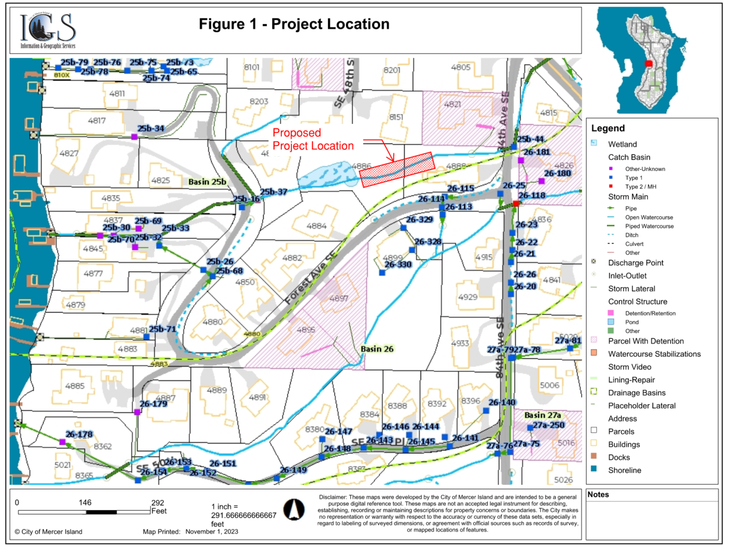
Figure 2 Wetland and Watercourse Sketch
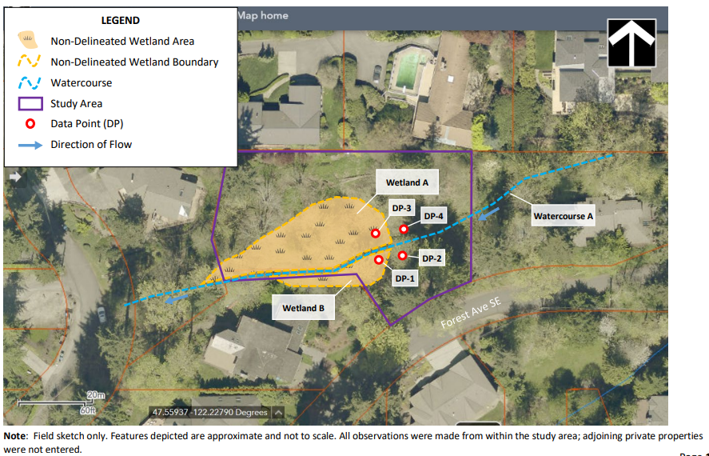

3.0 Critical Areas Impacts Assessment and Mitigation
This section provides a summary of proposed impacts and mitigation to avoid and minimize impacts. Project activities must avoid, minimize, and mitigate impacts to environmentally critical areas and associated buffers consistent with mitigation sequencing described in MICC 19.07.100. Mitigation sequencing and best management practices (BMPs) are described further in Section 4.

3.1 Wetlands & Watercourse Areas
The proposed work has been designed to avoid and/or minimize impacts of the delineated wetland areas to the greatest extent possible. The proposed project is upstream of the wetlands, no work for this project will occur within the wetlands. While working upstream and within the wetland buffers, impacts will be minimized through implementation of BMPs prior to and during construction activities. Examples of BMPs that may be used include establishment of staging areas, a stabilized construction entrance, and the use of silt fences, fiber rolls, and matting to protect vegetation and soils from vehicle impacts. Potential temporary wetland buffer impacts include installation of silt and construction fencing, and water quality impacts due to construction activities in upstream watercourse during vegetation removal.

The proposed work includes improvements to the channel of the watercourse to reduce erosion and improve stability. Permanent impacts to the stream channel include regrading and reconstruction of the channel, filling the incised areas, placing submerged rock weirs below the proposed channel bottom, placing plantings along the stream channel banks and installation of logs or large woody debris. The total area of disturbance within the combined wetland and watercourse buffers is 5,733 square feet. All disturbed areas will be restored by removing invasive species and replanting native plants. See Section 4.0.

The following mitigation plan addresses impacts to the wetlands and watercourse. All erosion and sediment controls will be installed prior to construction activities. All existing vegetation adjacent to the mitigation areas will be preserved to the greatest extent possible and seeded with a native seed mix, if necessary, immediately following ground disturbing activities. The contractor is required to strictly adhere to the City’s Stormwater Prevention Pollution Plan (SWPPP) and the site-specific Construction SWPPP during construction. Mitigation and restoration will occur after completion of the project to return any disturbed areas to pre-construction condition.

3.2 Geologically Hazardous Areas
The construction will include clearing of vegetation, and excavation of soils from watercourse channel, as well as regrading channel. Based on soil conditions encountered at the hand boring locations taken during field work and the relatively steep slopes in the drainages, the near-surface soils are likely to exhibit erosion potential. Erosion hazards at the site can be effectively mitigated with the BMPs during construction and with properly designed and implemented landscaping for permanent erosion control.

4.0 Mitigation Sequencing and Best Management Practices
The City requires Projects to implement mitigation sequencing as described in MICC 19.07.100. The following summarizes how the project fulfills each step in the mitigation sequencing process:

- Avoiding the impact altogether by not taking a certain action or parts of an action. The project is designed to include the minimum necessary impacts to critical areas to support the purpose of the project goals.
The purpose of this project is to reduce downcutting and erosion in the channel. The project site has experienced significant downcutting resulting in the formation of near vertical banks. This project intends to utilize logs, rock weir, large woody debris, and streambed sediment to reduce erosion by slowing flow and decreasing shear stress on the channel bottom.

Potential impacts have been considered while evaluating methods of construction, construction materials, and physically accessing the site is necessary to avoid impacts as much as possible.

B. Minimizing impacts by limiting the degree or magnitude of the action and its implementation. Site access will be limited to and from one location at the site therefore minimizing impacts to the side slopes. Staging will be limited to one location. All work will be done during dry weather conditions, in July and August.

During construction, any existing flow will be temporarily bypassed.

Silt fences will be installed to control erosion and soil movement. In addition, construction of ditches and earthen berms will be constructed to collect runoff and prevent soil movement. Silt fences will be monitored by checking weekly or after large storm events to ensure that fences are in place and functioning.

The project intends to limit activity, as much as possible, to the channel bed extents. The project design limits vegetation removal and soil disturbance to the minimum needed. Excavation of unsuitable soil will be promptly followed by the replacement and compaction of clean structural fill.

The stabilization treatment/ implementation methods being installed are designed to mimic the natural occurrence of streambed stabilization. No impervious surface will be added to the site.

The stabilization treatments are:
- Bed Control Matrix Structures- The bed control structures (submerged rock weirs) are constructed with six one-man boulders arranged across the channel to prevent downcutting.
- Timber frame structures- The timber frame structures (log cross vanes, bank-logs, and log barbs) are log formations that create and support pockets of soil on the banks where native plants will be planted. The timber frames will provide immediate relief to the banks and greatly reduce the current rate of sediment delivery from the hillside to the channel. As the vegetation becomes more established it will provide long-term stabilization of the banks.
- Streambed Cobbles- The placement of a mixture of 12-, 10-, and 6-inch cobbles, plus streambed sediment with the channel of the watercourse is designed to be a stable mix of coarse aggregate that will not be mobilized during higher flows.

Downstream storm pipes will be inspected prior to the start of the construction activities and after the completion of the construction activities to ensure no materials from the site have entered the pipes.

C. Rectifying the impact by repairing, rehabilitating, or restoring the affected environment. The project goal is to repair, rehabilitate, and restore the environment impacts caused by active erosion. Areas that are disturbed during construction will be replanted with native plants at the end of the project. When preparing the access and staging areas, invasive species located within those areas will be removed. All removed plant material shall be disposed of off-site. New native plants will be planted at the end of the project. No permanent impacts will occur and the areas that are replanted will provide an equal or greater ecological value.

D. Reducing or eliminating the impact over time by preservation and maintenance operations during the life of the action. Impacting action will halt when the project is completed. During construction, contractor shall:
- The Contractor shall be responsible for the protection and preservation of all existing native vegetation including trees, shrubs, and other objects outside of the project limits of the staging areas and access paths.
- Contractor shall not clear vegetation greater than 6” in diameter without prior Engineer approval (inside the project limits).
- Any existing trees greater than 6” in diameter in close proximity to the staging area and access routes and shall be protected from damage per notes provided on the Plans to prevent equipment from coming in contact with the trees; vehicles and/or heavy equipment may not travel within the critical root zone. Any removal of limbs required to establish and maintain access shall be flagged for review and approval by Engineer or Representative before any limbs are removed.
- Any existing tree or shrub located outside of the staging areas and access paths that are damaged or destroyed during construction shall be replaced in like type and size as indicated by the Engineer.
- In areas where the soil is disturbed during vegetation removal, the soil will be stabilized in-place.

E. Compensating for the impact by replacing, enhancing, or providing substitute resources or environments. In addition to re-planting the access and staging areas, other areas within the project limit will also receive invasive removal treatment and be planted with native plants to develop a stable riparian corridor. The project limit is typically a 10 ft buffer from the outer edge of access. Any fill needed for the incised channel will be streambed sediment, conforming to requirements of WSDOT 9-03.11(1).

F. Monitoring the impact and taking appropriate corrective measures to maintain the integrity of compensating measures. The City will develop a maintenance and monitoring plan for all installed plantings to ensure success.

To avoid or minimize potential adverse impacts to the aquatic environment, the following BMPs will be employed during construction:

- Applicable permits for the project will be obtained prior to construction. Work will be performed according to the requirements and conditions of these permits.
- In-water work will occur during the approved regulatory work window; expected to be July 1 to August 31.
- The contractor will be responsible for the preparation and implementation of a spill plan to be used for the duration of construction, which will include spill prevention, control, and response BMPs. In addition, the spill plan will outline roles and responsibilities, notifications, inspections, and response protocols to be implemented in the event of an inadvertent spill during construction. Contractor will prepare a Construction SWPPP.
- The contractor will supply to the Project Engineers a Temporary Erosion and Sediment Control (TESC) Plan and/or a Construction SWPPP that will use BMPs to prevent erosion and sediment-laden runoff from leaving the site. These plans will be implemented prior to the start of ground-disturbing activities. All areas disturbed by Project construction will be stabilized as soon as possible to prevent erosion and re-vegetated as soon as practicable post-construction and prior to the removal of TESC/SWPPP measures.
- Excess or waste materials will be wastehauled by the contractor and not disposed of or abandoned on site or allowed to enter the waters of the state.
- No petroleum products, chemicals, or other toxic or deleterious materials will be allowed to enter surface waters. Any spills will be cleaned-up immediately in accordance with SWPPP.

